BUILDING BUS RESERVATION SYSTEM USING PYTHON &DJANGO

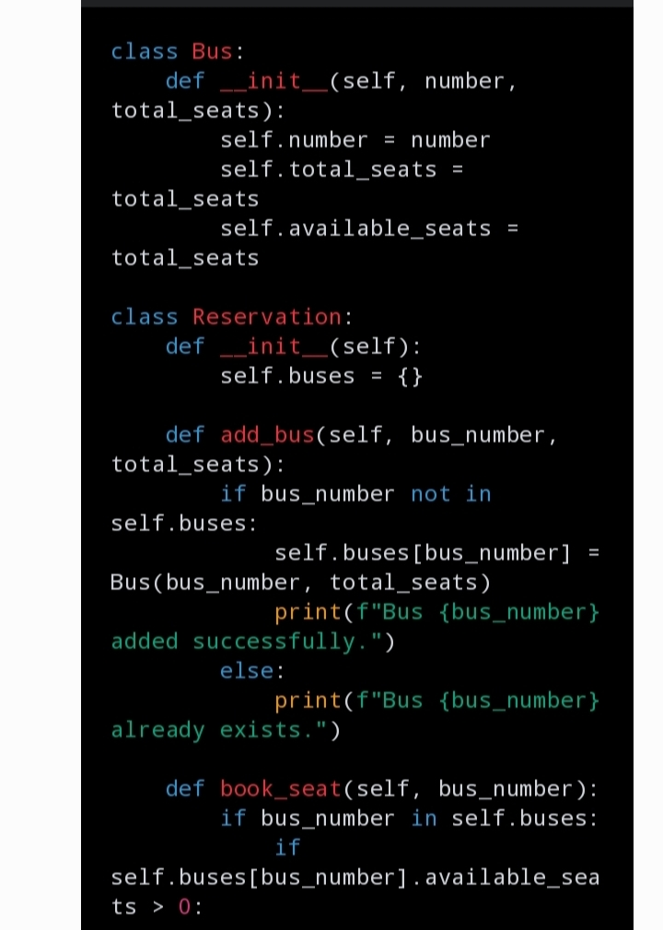

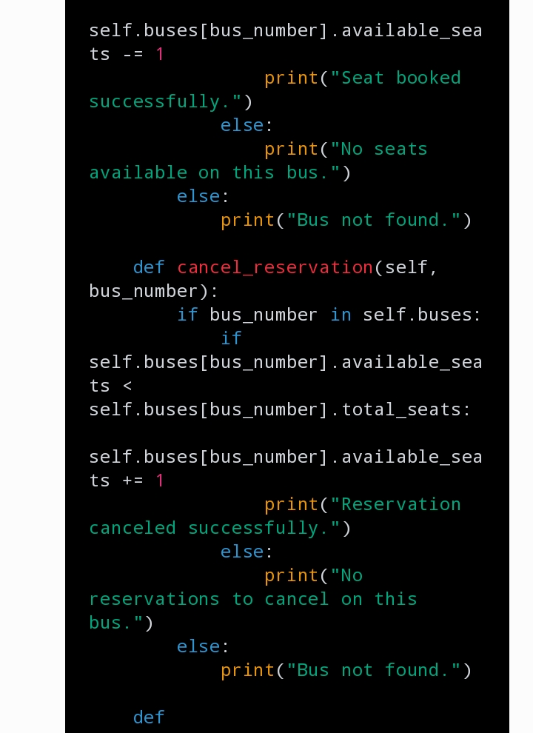

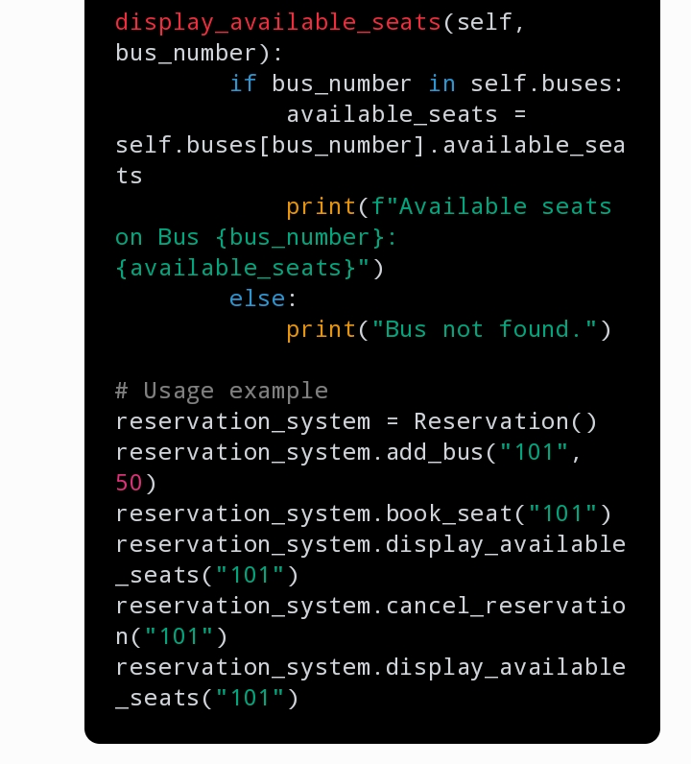

OUTPUT

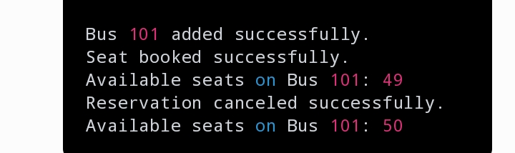

THANK YOU